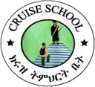

E- mail: cruiseschoolet.et 27188 web site: www.cruiseschool.net.com
KG-1 campus 0113-724400 / 0113-206005 KG-2campus 0113-711683KG-30118-391527
Name: _________________________ LKG Section: ______Roll no.______
2012E.C Second Semester English Work Sheet
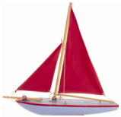
- Match the words with pictures .
yacht
zebra
x-mas
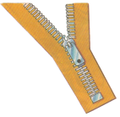
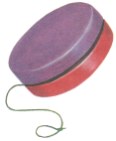
yo-yo
zip
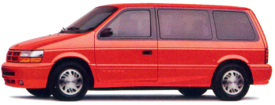
II.Name the pictures .
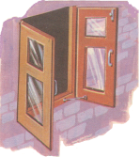

____________ ____________
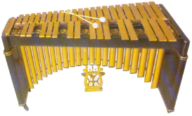

____________ ____________
Page 1

III.Write the letters in ’’a b c’’ order .
h i g j l k
___ ___ ___ ___ ___ ___

o p m q n
___ ___ ___ ___ ___

IV.Make words by the given letters .

j ____________, ____________
n____________, ____________
s ____________, ____________
q____________, ____________
Page2

